- DIGITAL MARKETING PROGRESS REPORT
MEMBERS:
1-LEADER (MUHAMMAD MEHRAN AMJAD (103)
2-FAISAL JAVED (114)
DESCRIPTION:
FIRSTLY I will show some Progress of my own business that I will do and I continue to working on it further processing on different marketing strategies sales:
- I am working on forever platform as Seller
- Selling products and Accounts on social media
- I have a good link with a Marketers and have a sales on these products
- Plenty of customers again buying from me and my sales continue to peak
- I have working on these marketing strategies from 1.5 years
- And have a good experience of running ads on meta
- Generating a lots of leads from meta ads
- A lots of customers become organic after running from ads and have to contact to me

SCREENSHOTS: 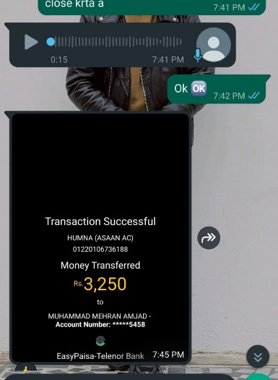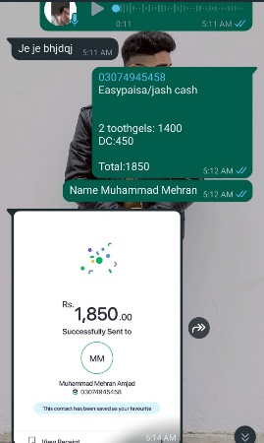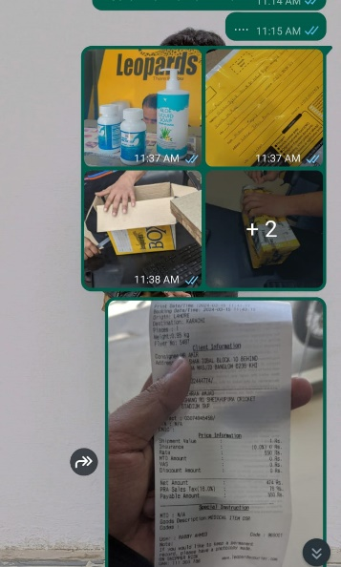
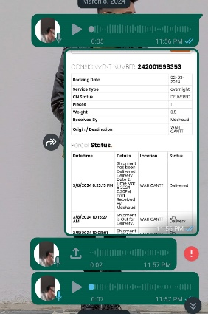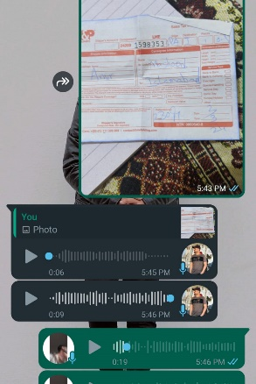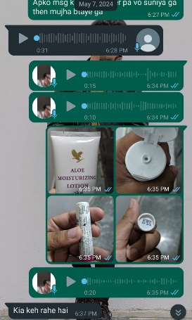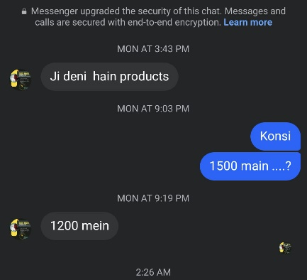

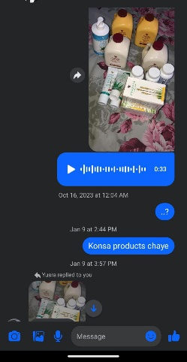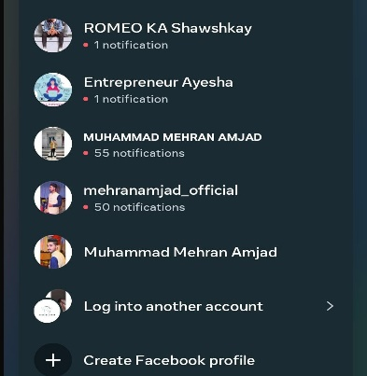

- THESE SS IS ONLY RECENTLY SALES OF MY PRODUCTS AND FURTHER SALES PROCEEDING ..
- And the pages of facebook where I used to connect with people and to contact for sales
2-DROPSHIPPING:
As when we take classes of Digital marketing I used to learn how I can generate sales after getting profit of margins of different platforms products working on different platforms like …
- Shopify
- Markaz
- Facebook marketplace
- Aliexpress

- In shopify I used to make a web but not yet work more on this plateform just gaining experience and used to cart products for selling..
- In markaz I have working much but not yet getting orders to much because of shop owners high product cost but some of the orders I get and earn profits from these sales
SCREENSHOTS:
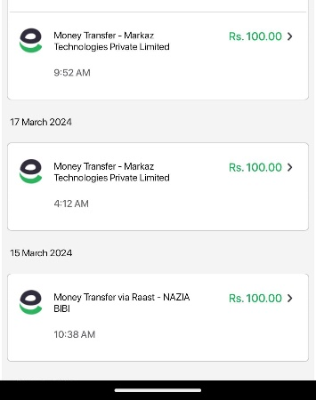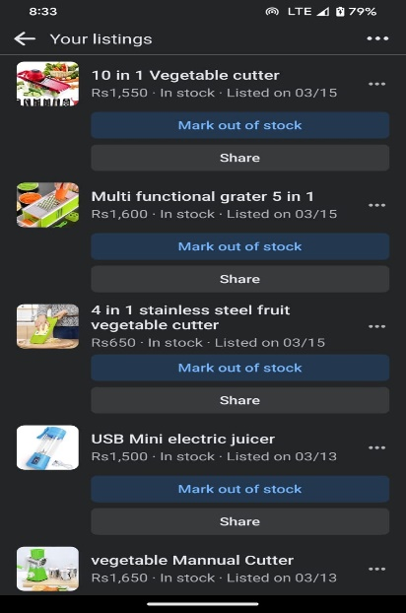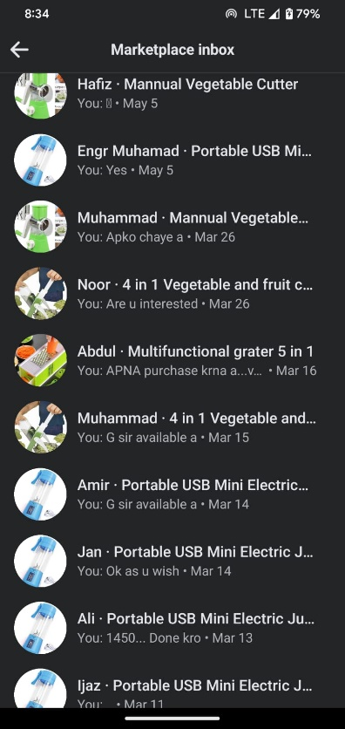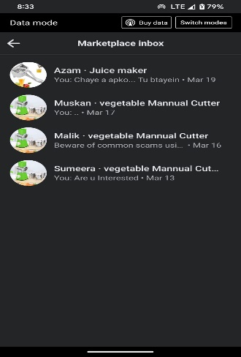

And on shopify:
- I just used to listing mapped add products just for gaining experience from this platform for dropshipping
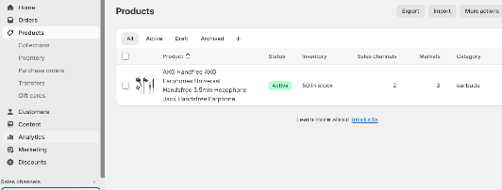
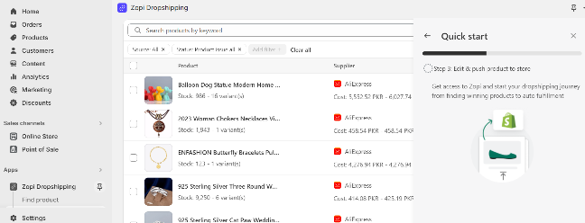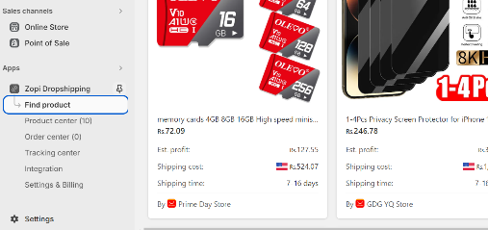

MY ACCOUNTS AND PAGES:
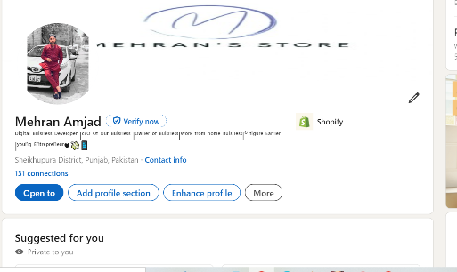
linkedin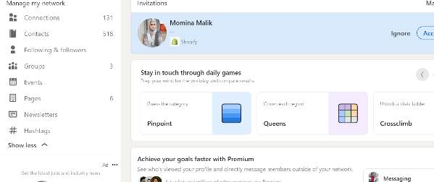

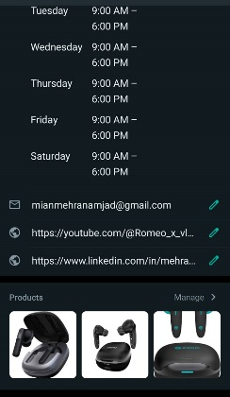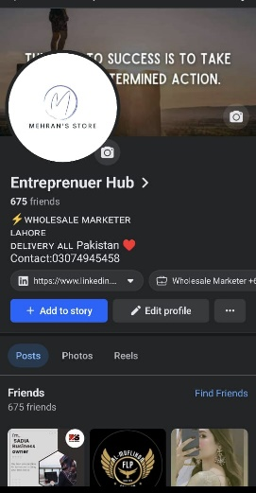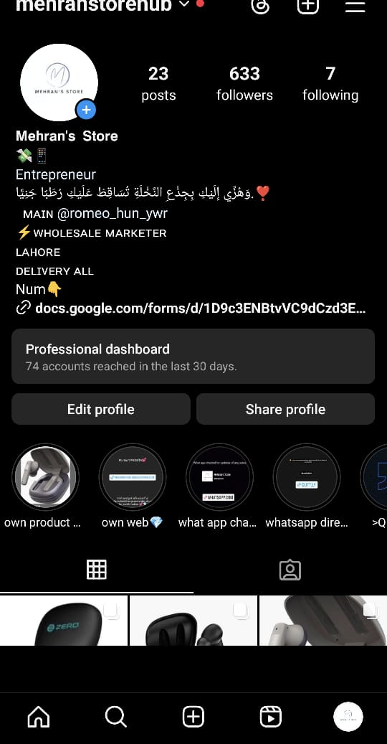
Whatsapp/facebook/instagram
MY OWN WEBSITE FOR E-commerce wholeselling:
http://mehranstore.xddevelopers.com/
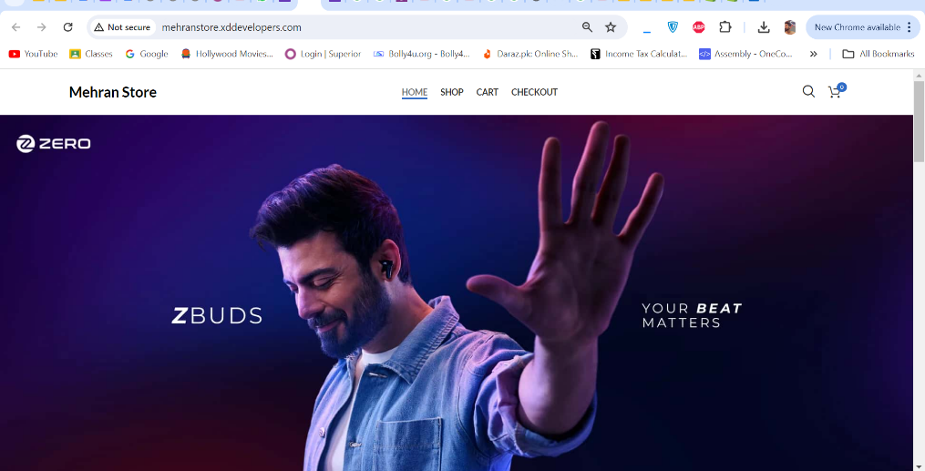
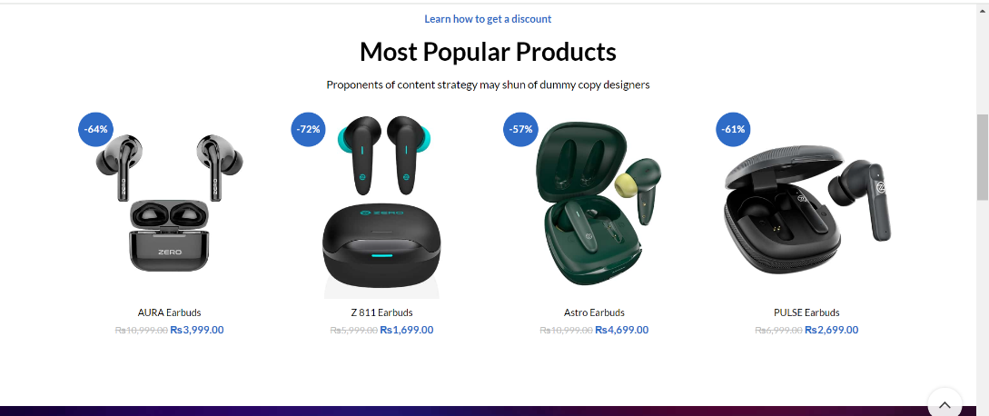
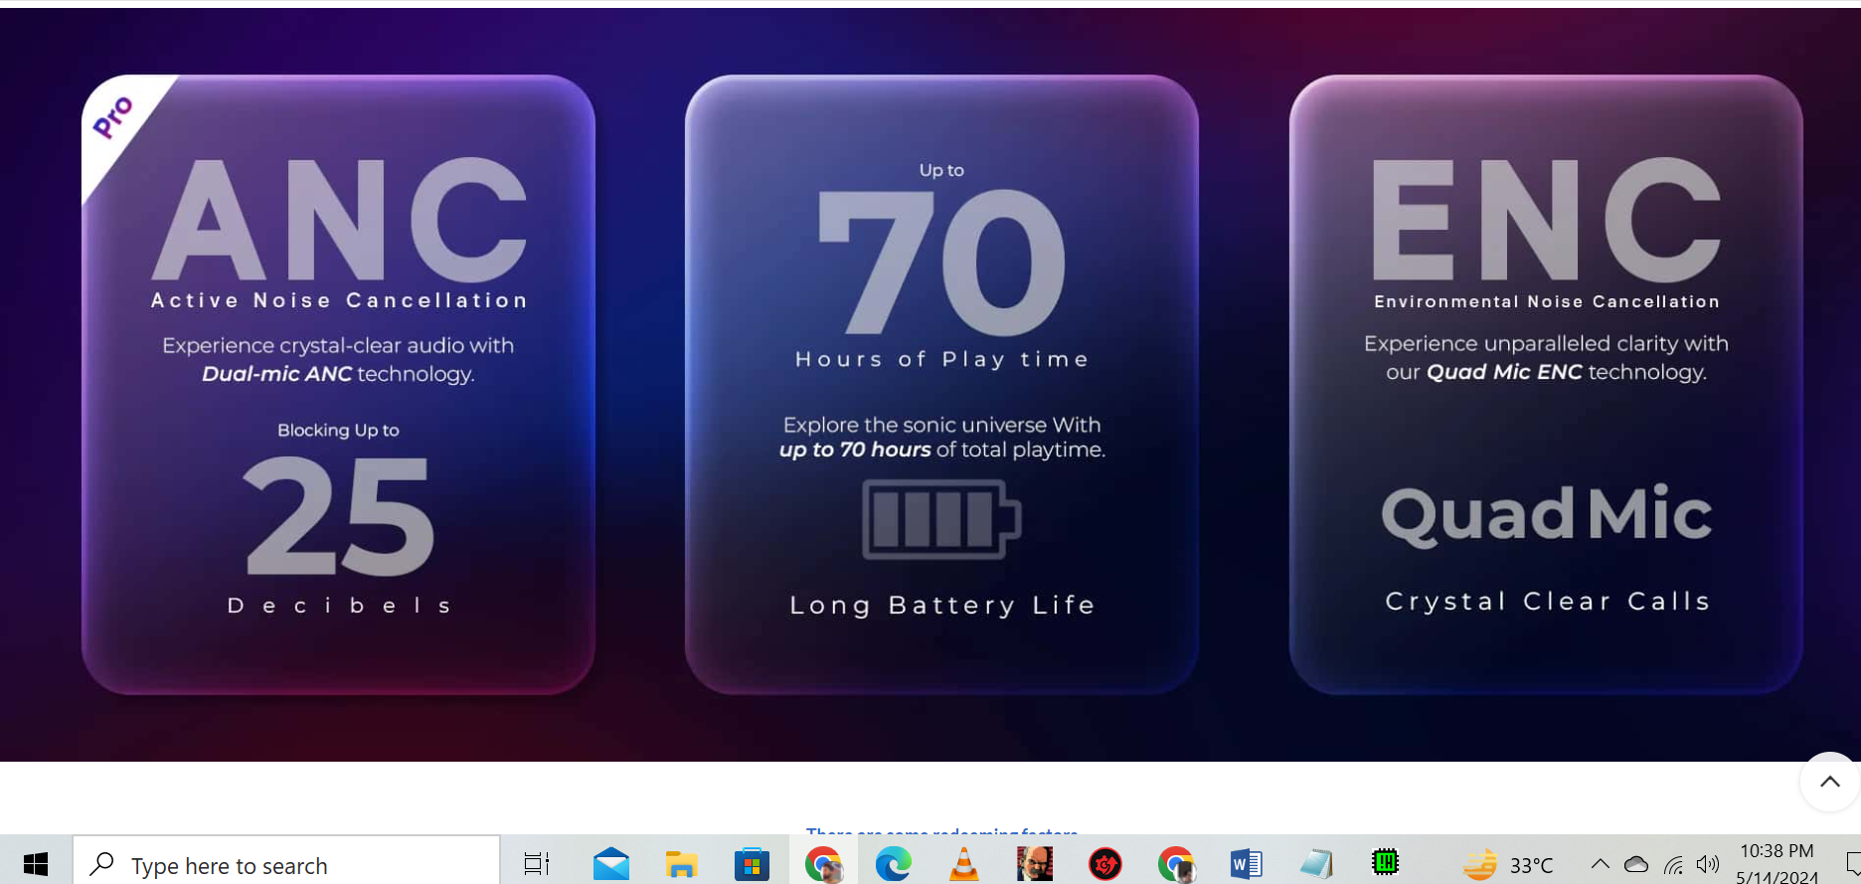
- I used to work and make a web to sell services and products
- purchase domain/hosting running adds linking web to get sells
- I will show u how I can market these products in social media organically or inorganically.
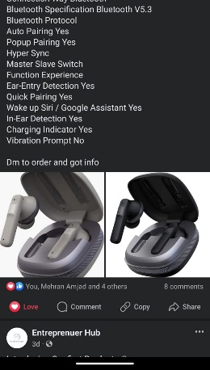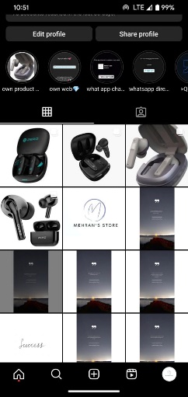

- Now I will show u sales of these products by Screenshots then completion of orders from login….
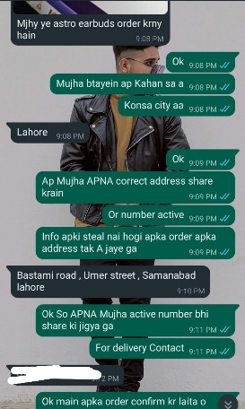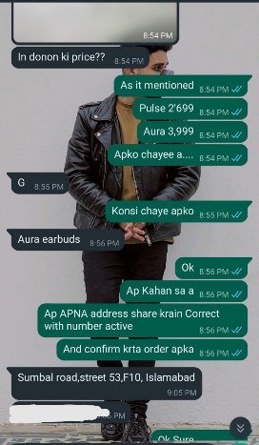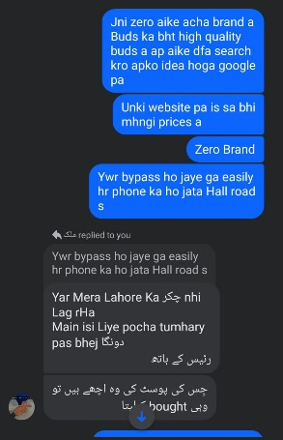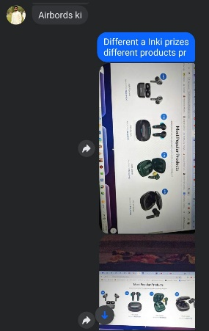

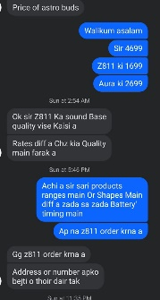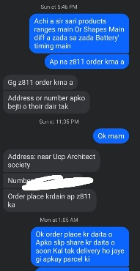

WEB ORDERS AND SALES:
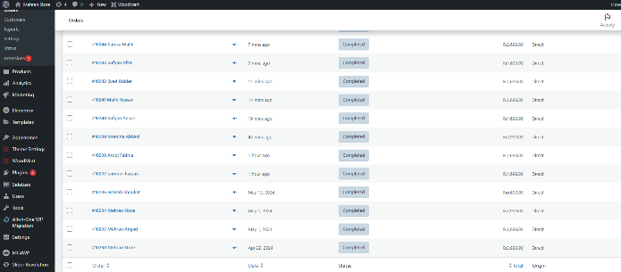
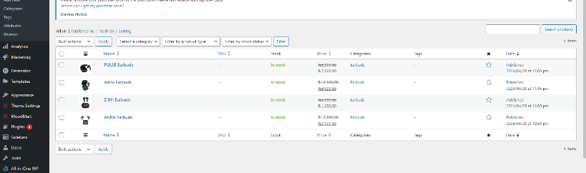
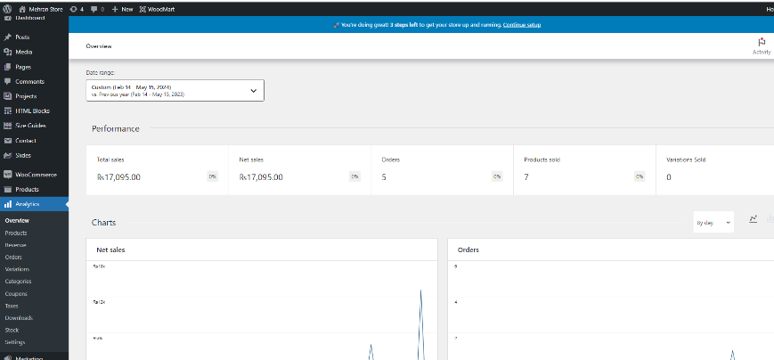
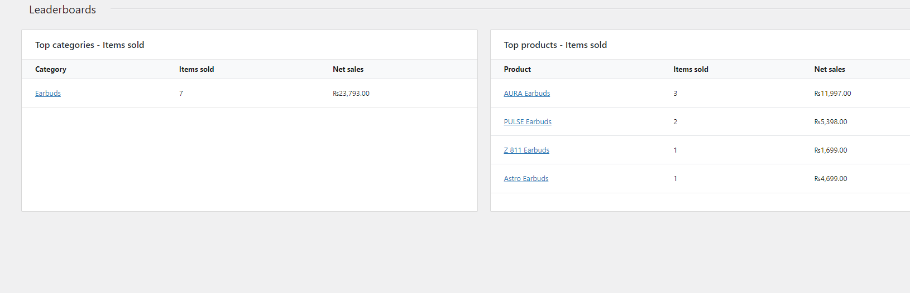

META ADS PROGRESS:
- Sir my acc got hacked in ramadan and the hacker delete all my compains from my web but proofs of my Payments has been stored on my bank accounts…
- I have payment slips of compain ads I will show u now

- Proof my running ads on both of my business currently my team got working on running ads I just contact and marketing with people for selling…
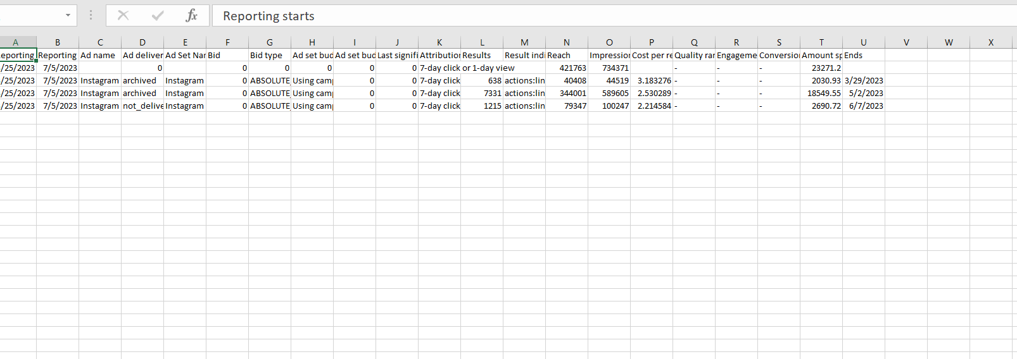
- My Compains being deleted by hacker but some proofs will be shown of my compains.

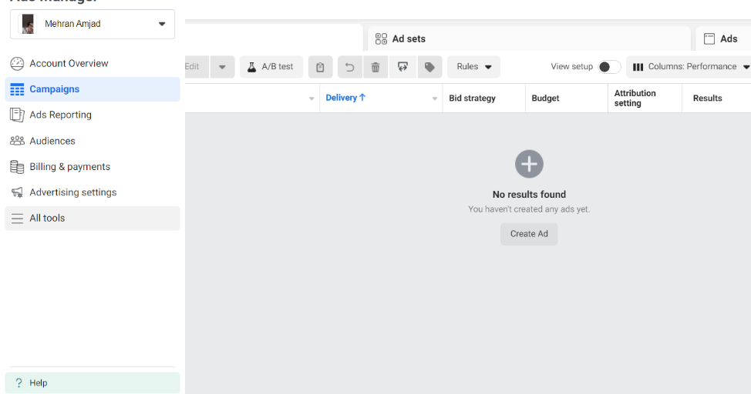
Proofs of Ss of Payments:
TRANSACTIONS:
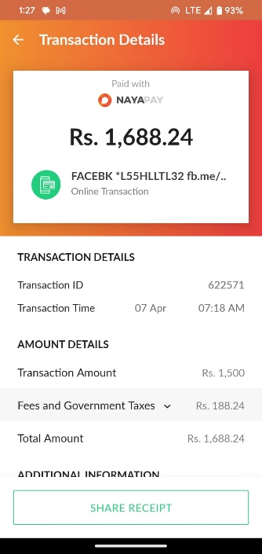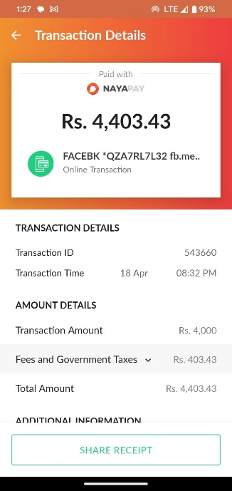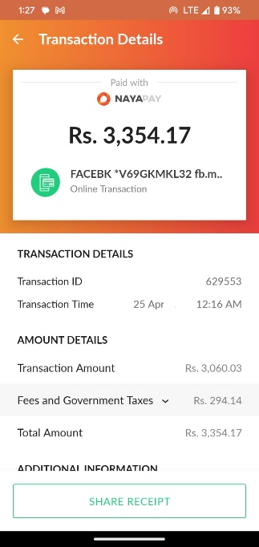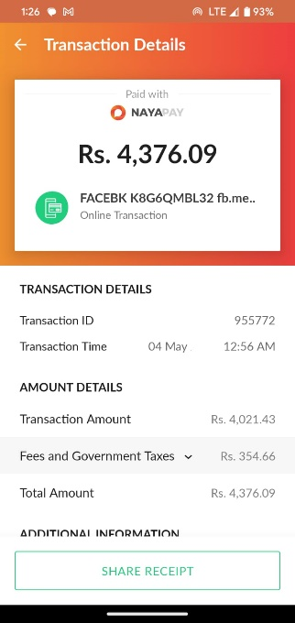
Proofs of my Fb/insta ads:

